10.16: This is the same situtation as in Example 10.3. a) 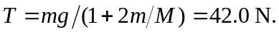
b) 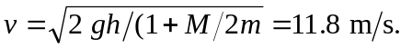 c) There are many ways to find the time of fall. Rather than make the intermediate calculation of the acceleration, the time is the distance divided by the average speed, or 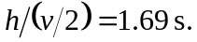 d) The normal force in Fig. (10.10(b)) is the sum of the tension found in part (a) and the weight of the windlass, a total 159.6 N (keeping extra figures in part ( a)).

